#include<stdio.h>

float wqicalc(float p, float q, float r);

int main()
{
float pH, DO, turbidity, wqi;

printf("Enter pH value of the water: ");
scanf("%f", &pH);

printf("Enter percentage of dissolved Oxygen in the water: ");
scanf("%f", &DO);

printf("Enter Turbidity value of the water: ");
scanf("%f", &turbidity);

wqi = wqicalc(pH, DO, turbidity);

printf("The quality of the given sample of water is %.2f\n", wqi);

if (wqi > 0 && wqi < 50)
{
printf("The Quality of water is Satisfactory\n");
}
else if (wqi >= 50 && wqi < 100)
{
printf("The Quality of Water is Moderate\n");
}
else
{
printf("The Quality of Water is Poor\n");
}

return 0;
}

float wqicalc(float p, float q, float r)
{
float r1;
r1 = (p * 10) + (r * 5) + ((100 - q) * 2);
return r1;
}

OUTPUT:
Step1: Enter value of pH, Dissolved Oxygen Percentage and turbidity
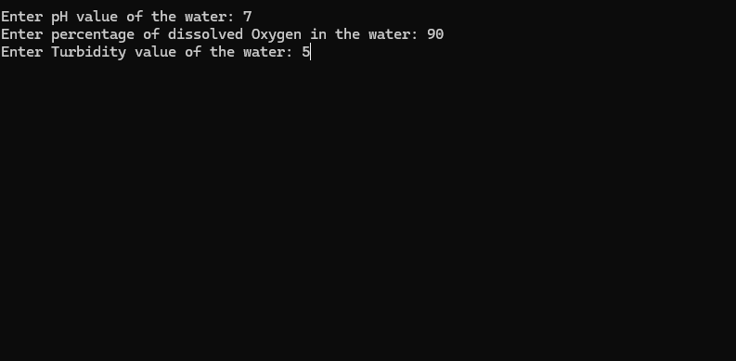

Step2: Final output
